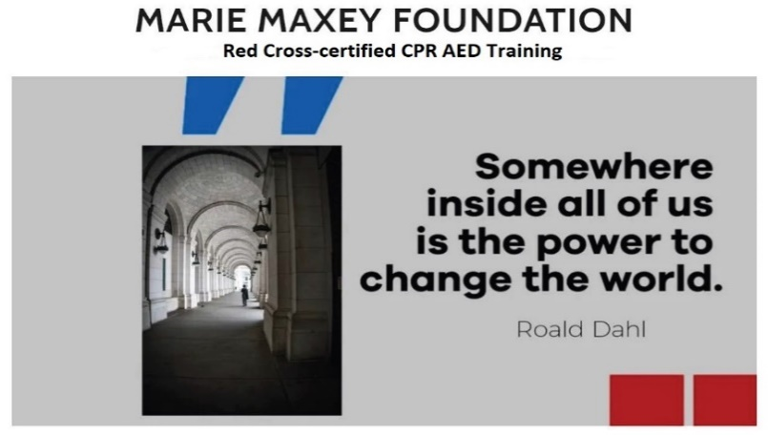


Financial Stewardship Report
A Seven-Year Review of the Marie Maxey Foundation (2019–2025)
Prepared March 2026
Since our founding in late 2018, the Marie Maxey Foundation has operated on a simple principle: every dollar entrusted to us should reach the people it is meant to serve. This report provides a transparent account of how your contributions have been managed over seven years and how our financial stewardship has evolved as we have grown from a small family effort into a nationally active nonprofit.
From Modest Beginnings to Meaningful Impact
In 2019, our first full year of operations, 15 donors contributed $2,703. We awarded a single $500 scholarship to a Dreamer college student in Chicago. Our expenses were minimal: logo, business cards, software, and bank fees. We had no staff, no office, and no overhead. That remains true today.
By 2020, donations nearly doubled to $3,950 from 20 donors, and we awarded 18 scholarships totaling $3,450 through three named memorial scholarship funds: Dulce Deinken, Elena Bathrick, and Chris Goughnour scholarships. Every dollar raised went directly to students.
In 2021, we experienced a breakthrough. Donations surged 109% percent to $8,268 from 27 donors. We provided 12 scholarships worth $7,500 (this included an English language training program in Honduras for $1,000). Total expenditure reached $7,813, with administrative costs of just $313 — about four percent of spending. This set the standard we have maintained ever since.
In 2022, we expanded beyond scholarships for the first time, investing $2,700 in a preventative healthcare program in San Luis, Santa Bárbara, Honduras. We shipped AED defibrillators, blood pressure monitors, and CPR training equipment to local clinics. Total donations were $7,304 from 14 donors, with the average donation rising to $522 as our donor base became more committed.
The year 2023 marked a turning point. Donations more than doubled to $15,440 from 32 donors — our largest donor base to date. We awarded $11,000 in scholarships across nine named memorial funds and invested $4,400 in health activities, including the purchase of a Spanish-language AED ($1,610), CPR/AED training equipment ($1,390), and a $1,500 grant to Woven with Hope to support Bedouin Arab women in North Africa. Administrative costs were $820, or five percent of total expenditures of $16,320.
In 2024, we maintained our fundraising momentum with $15,566 from 18 donors, with the average donation climbing to $865. We launched the Heart Program, our Red Cross CPR/AED training initiative for underserved communities in Fairfax County, Virginia. Nine scholarships totaling $8,500 were awarded to students in Virginia, Mississippi, and West Virginia. Twelve CPR/AED training sessions certified 49 individuals. Total expenditures were $12,907, with administrative costs at $1,009 or 7.5 percent — slightly higher due to a one-time computer purchase ($500) and liability insurance required for Red Cross training.
In 2025, our most ambitious year, total funding reached $38,994. Individual donations grew 11 percent to $17,484 from 17 donors, and we were awarded a $21,500 grant from the INOVA Community Health Fund to expand CPR/AED training across Fairfax County. We awarded ten scholarships valued at $14,450 and received over 600 applications for our scholarship program — a testament to the growing need and the growing recognition of our work. On the health side, we certified 66 residents in CPR/AED and provided orientation to 232 more through community health fairs. We ended the year with a balance of $20,103, the strongest financial position in our history.
Seven-Year Financial Summary
Year | Donations | Donors | Scholarships  & Programs | Health/CPR | Admin | Admin % | Year-End Bal.
2019 | $2,703 | 15 | $500 | $0 | $215 | ~8% | $790
2020 | $3,950 | 20 | $3,450 | $0 | $0 | 0% | $1,141
2021 | $8,268 | 27 | $7,500 | $0 | $313 | 4% | $1,909
2022 | $7,304 | 14 | $4,500 | $2,700 | $420 | 5% | $5,744
2023 | $15,440 | 32 | $11,000 | $4,500 | $820 | 5% | $2,841
2024 | $15,566 | 18 | $8,500 | $3,398 | $1,009 | 7.8% | $5,500
2025 | $38,994 | 17 | $14,450 | $8,825 | $1,116 | 4.6% | $20,103
TOTAL | $92,225 | 80+ | $49,900 | $19,450 | $3,893 | ~5% | $20,103
Where Your Money Goes
We are proud that since our founding, administrative costs have averaged approximately five percent of total expenditures. The remaining 95 percent has gone directly to the people we serve — scholarship recipients, CPR/AED trainees, healthcare workers in Honduras, and communities in need. We have no paid staff. Our Executive Director, board members, and volunteers donate their time. There is no office rent, no executive compensation, and no overhead beyond the basic costs of maintaining our website, filing state and federal requirements, and communicating with donors.
The following table shows how expenditures have been allocated across our major program areas over the past four years:
Category | 2022 |  | 2023 | 2024 | 2025
Scholarships & Grants | $4,500 | $11,000 |  | $8,500 | $14,450
CPR/AED Training & Equipment | $2,700 | $3,000 |  | $3,220 | $8,825
Community Support (Woven w/ Hope, etc.) | $0 | $1,500 |  | $0 | $0
Fundraising (mail, postage, meetings) | $0 | $564 |  | $814 | $446
Administrative (website, fees, insurance) | $420 | $256 |  | $695 | $670
Total Expenditures | $7,620 | $16,320 |  | $12,907 | $24,391
Key Financial Trends
Donation growth: Total donations have increased more than fourteen-fold, from $2,703 in 2019 to $38,994 in 2025. Individual donations have grown steadily each year, while the INOVA grant in 2025 marked our first institutional funding.
Average donation: The average individual donation has risen from $180 in 2019 to $1,029 in 2025, reflecting deeper engagement and trust from our donor base.
Program diversification: We began as a scholarship-only organization. By 2022, we added healthcare programming. By 2024, we launched CPR/AED training. Today, scholarships represent about 60 percent of expenditures, health initiatives about 35 percent, and administration about 5 percent.
Financial stability: Our year-end balance has grown from $790 in 2019 to $20,103 in 2025, providing a solid foundation for planned 2026 activities.
Our Commitment to Accountability
The Marie Maxey Foundation files an annual IRS Form 990-N and maintains complete financial records including monthly bank statements, donation receipts, and scholarship award documentation. Our annual reports, financial statements, and board meeting minutes are available to donors upon request. The foundation’s Treasurer certifies the accuracy of all financial statements, and the board reviews and approves the annual budget and expenditures at each annual meeting.
We believe that trust is earned through transparency. When you give to the Marie Maxey Foundation, you can be confident that your donation is being managed with integrity and directed to the people and programs that need it most.
Looking Ahead
For 2026, we plan to fund approximately $15,000 in scholarships focused on youth from underserved communities in Mississippi and across the nation, while seeking $30,000 for healthcare initiatives in Fairfax County, Virginia, and rural Mississippi. We will complete the INOVA Community Health Fund grant, continue building sustainable CPR/AED training capacity, and explore ways to address the healthcare access challenges facing rural Mississippians.
None of this would be possible without you. Over seven years, more than 80 donors from across the United States and abroad have contributed over $92,000 to our mission. You have funded more than 60 scholarships, trained over 300 residents in life-saving skills, and brought hope to communities from Fairfax County, Virginia to Grenada, Mississippi to San Luis, Honduras.
Please consider a tax-deductible gift at: www.maxeys.org/donate
Together, we can change the world.
With gratitude and accountability,
Michael Maxey
Executive Director, Marie Maxey Foundation
www.maxeys.org

Beginning with 2026 tax year, taxpayers who do not itemize may deduct up to $1,000 in cash donations to 501c3 organizations – up to $2,000 for married couples filing jointly.
Marie Maxey Foundation • EIN: 83-1473076 • 5525 Talon Court, Fairfax, Virginia 22032

